TESTING – Launching accuracy

Project: Design an Autonomous Robot

Task: To design an autonomous robot that is capable of navigating to a predetermined position while avoiding obstacles and firing objects at two targets. This is to be done in the shortest time possible.

Document Version Number: 3.0

Date: April 5, 2015

Tester: Yu Chen Xu

Software Version: 1.0

Hardware Version: 4.0

Goal: The goal of this test is to know if the robot’s launcher can hit a target closed to the wall in a competition enclosure simulation.

Table of Contents

Purpose 3

Objectives 3

Procedure 3

Expected Results 3

Format of Output Required 4

Sample Calculations 4

Test Report 4

Conclusion 4

Action 5

Distribution 5

# Purpose

The purpose of the test is to see if the robot can shoot the ball in a parabolic trajectory in order to hit a target placed close to the wall. During the competition, the second target is more difficult to hit compared to the first one, because it might be placed at 30cm from a 20cm high wall. Therefore, the only way to hit it would be to shoot the ball in a parabolic trajectory. In the previous hardware versions of the robot, the balls are shouted with a small initial angle, almost parallel to the ground. Hence, it is nearly impossible to hit a target close to the wall, because it will either hit on the wall or it will miss the target by flying over it. In this test, the hardware version used is the latest one, V4.0, where the initial angle is bigger. A better explanation of the newest hardware version can be found in the Week 6 docs.

A testing code that can be found in the “Launching test” folder.

# Objectives

The objective of the test is to improve the ability of the robot to shoot targets placed close to the wall.

This test is a simulation of the shooting part of the competition. Since the competition will be held at an indoor place, there will not be any factors that affect the launching of ball. Therefore, it is correct to assume that doing the test in the lab room can represent well the real situation.

# Procedure

1. Place the robot at a position (0, 0) (i.e.: at an intersection of the grids).
2. Place a wall of 20cm high at (0, 60)
3. Place a target of 7.5 cm radius at (0, 90)
4. Launch a Ping-Pong ball along with the loading mechanism.
5. Note the X and Y components of the landing spot.
6. Repeat step 4) and 5) 10 times.

# Expected Results

The expected result is that the ball will land near (0, 100), after flying above the wall.

The best case of the test is that the ball will land near (0, 100) with a 7.5 cm radius error in 100% of the cases. This will prove the accuracy and the exactness of the launcher. The worst case scenario of the test would be that the landing spot is more than 7.5cm far from the desired point (0, 100) in 100% of the trials.

As for the loading system, it is expected that it can load balls without human intervention.

# Format of Output Required

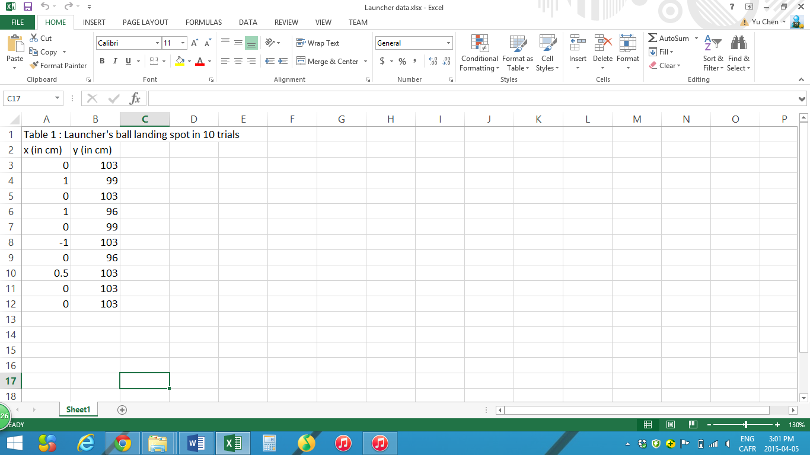

This table can be found in the “Launcher data.xlsx”.

# Sample Calculations

The mean value can be obtained by the following formula: $μ=\frac{1}{N}\sum_{i=1}^{N}{Xi}$

EX: For X-axis mean, $μ= \frac{\left(0\right)+\left(1\right)+\left(0\right)+…+\left(0.5\right)+\left(0\right)+(0)}{10}= -0.15 cm$

In this test, the mean values for x-axis and y-axis are respectively -0.15 and 100.8 cm.

The standard deviation can be obtained as $σ= \sqrt{\frac{\sum_{i=1}^{N}{({Xi-μ)}^{2}}}{N-1}}$

In this test, the standard deviation for x-axis and y-axis are respectively 0 and 3.11 cm.

# Test Report

The collected results are very positive as the launcher can be considered accurate, as the standard deviation values are 0 and 3.11 cm for each axis respectively. One positive thing observed is that every shot can produce a parabolic curve and the ball can land safely on the target, even if it is near the wall.

# Conclusion

This testing can be considered “passed” as the observed output is closed to the expected results. The trajectory of the ball is now parabolic and can reach targets placed near the wall.

On each axis, the ball always landed within a 7.5 cm radius. Last, the loading system still works well.

# Action

This test report should be keep within the mechanical team in order to bring adjustments to the launcher in the future.

# Distribution

This testing belongs to the mechanical development.